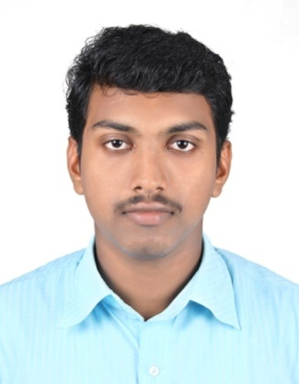
CURRICULUM VITAE

ARUN MOHAN K K
Email : arunmohankk99@gmail.com
Mobile : +91-8891723670
+91-9747996677
Objective:
Possessing good experience in the drilling field of Onshore & Offshore Oil & Gas facilities, seeking a challenging job in your organization where my skills, experience & education can be utilized to benefit the company.
Post applying for: ROUGHNECK / FLOOR MAN
Professional Certification:
- Elementary firs aid
- Fire prevention and basic fire fighting
- Personal survival technique
- Personal safety and social responsibility as per company rules
- H.U.E.T and sea survival course for offshore work
- H₂S & breathing apparatus training program
- Rigging and slinging techniques
- IADC Rig pass program ( IADCA4601195)
Work Experience:
I have worked in Shiv-Vani oil and gas exploration services Ltd. as a “Roustabout” From Dec 2012 to Aug 2013 and promoted as a “Floor Man” From Sep 2013 to Nov 2016 at Godavari (1500HP) in Ahmadabad Project.
Roles & Responsibilities:
- Keep the floor clean and tidy, clear of unnecessary Equipments.
- Keep clear all stairways in case of emergency
- Working with crane and forklift for loading and unloading in order with safe slinging practices, check load rating of different sizes of lifting equipment and proper crane operators signaling methods
- Prepare all tools and equipments for the next coming jobs.
- Keep well Control equipments in good reach. In good working condition & know how to use them in case of any emergency.
- Keep an eye for myself and co worker safety.
- Assists alone or as a member of a team, in all general duties such as house- keeping, washing, cleaning, needle gunning, priming and painting of areas on rig as directed.
- Placing thread protectors on drill pipes, collars, crossovers and casing being hoisted or stored
- Assist driller in rescue operations.
- Assist Derrick-man in chemical mixing including basic operation and maintenance of mud hopper
- Assisting in rig moves, tying of equipment and stores
- Observing safety rules regulations
- Participated in all safety meetings, courses and seminars conducted by the company
- Always reports unsafe conditions or practice to supervisor

Academic Qualification:
Qualifications | University/Board | Institution
High school | Kerala Board | Nanminda H.S.S
Higher Secondary | Kerala Board | Gov.H.S.S.Poonoor

Additional Qualification:
- Diploma in marine mechanical, 2010- 2012, college of marine technology at Kochi, India

- H₂S Monitor, gas Detector, Fire Detection System, DCP, Foam, CO₂, Fire Extinguisher, Life Jackets and Belts, Operations and maintenance of various types of fire-fighting equipment and well knowledge about fire and safety equipment

General Skills:
- Outstanding time management skills and ability to respond well in high -stress situations.
- Accept challenges with relative ease and work as a team.
- Languages can speak, write and read English, Malayalam, Hindi and Tamil.
- Win many time best “pre job card” and “stop card award”.

Personal Details:
Name : Arun Mohan
Sex : Male
Marital Status : Single
Nationality : Indian
Age / Date of Birth : 21 September, 1992
Language Known : English, Hindi, Urdu, Tamil and Malayalam
Passport Number : K 6239200
Date of issue : 27-09-2012
Date of Expiry : 26-09-2022
Place of Issue : Kozhikode, Kerala
Permanent Address : Arun Mohan K.K
Kakkukuzhiyil (house)
Kakkur (po)
Nanminda (via)
673613 (pin)
Kozhikode (dist)
Kerala, India

DECLARATION
I do hereby declare that the above mentioned information is true to the best of my knowledge and belief.

Place :
Date : ARUN MOHAN

